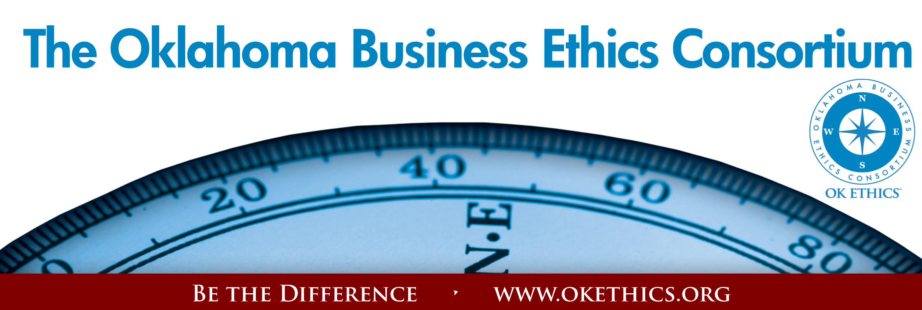
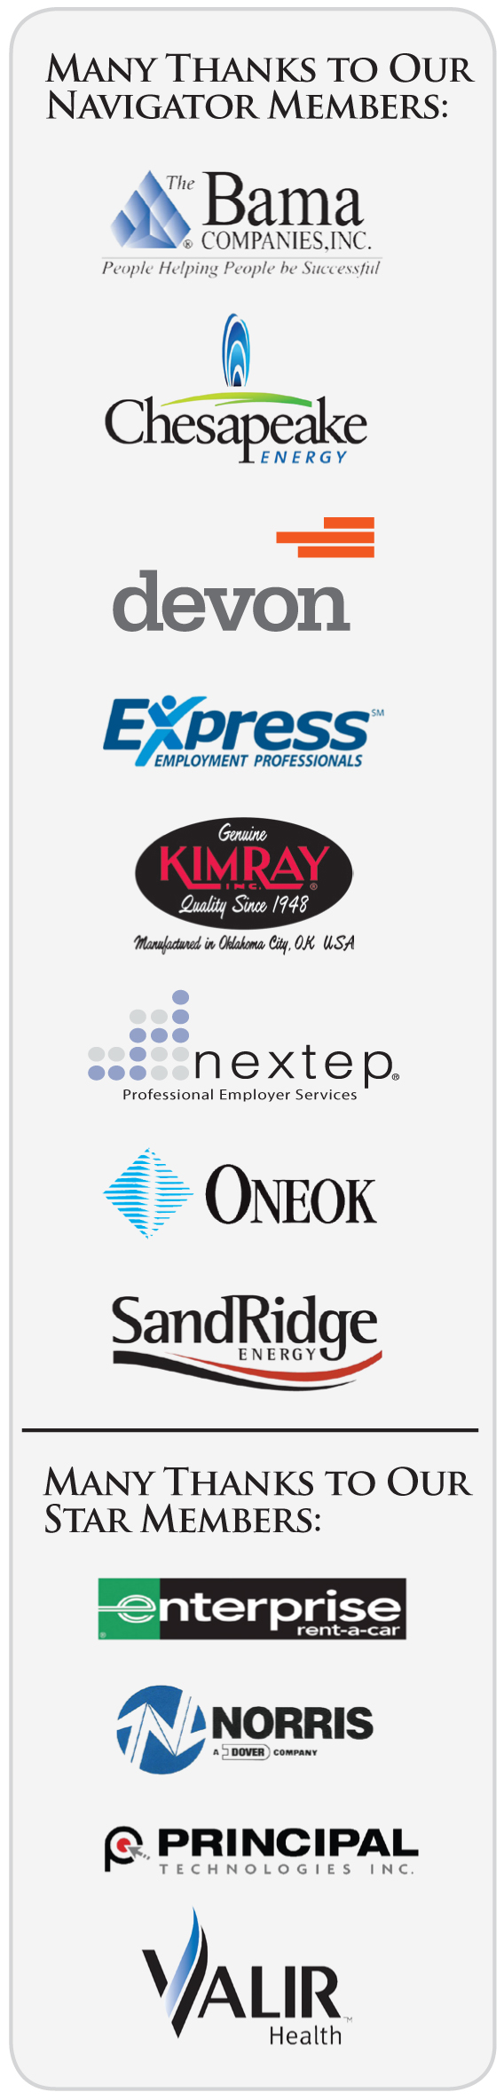
Agenda ~ Oklahoma City Chapter
March 11, 2009

I. WELCOME & KUDOS Shannon Warren, Founder
Oklahoma Business Ethics Consortium

VOLUNTEERS NEEDED

MENTORS NEEDED
Working with established student chapters at:
- Langston University
- Rose State College
To volunteer, call Bob Byrne
at Boeing (226-5060) or
Pam Fountain at Principal
Technologies (858-8800)
Registration Team & OK Ethics Ambassadors:
Greg Byers,
Sinclair Broadcasting Group – Registration Chair
Mary Kay Huggard,
Principal Technologies –
Registration Vice Chair
Terre Bettis, Coppermark Bank –
Chief Registration Emcee
Shannon Hiebert,
Enterprise Rent-A-Car -
Chief Ambassador
(& OK Ethics VP of Membership)
Mark Neumeister,
D.R. Payne & Associates, Inc. –
Registration Ambassador
Joe Walker, Grant Thornton -
Registration Ambassador
Lisa Giles, Eide Bailly, LLP –
Chief Identification Officer
(name badges)

CPE Certificates:
Colin Autin, Oklahoma Accountancy Board

AV & Pre-meeting Power Point:
Connie Barwick – Maximum Multi
Media Creations
Photocopies: Marilyn Carter and Ivy Rogers - Metro Technology Centers
Bobby Redinger - Cole & Reed (Agendas)
“At times, our own light goes out and is rekindled by a spark from another person.
Each of us has cause to think with deep gratitude of those who have lighted the
flame within us. – Albert Schweitzer
Special thanks to: Deborah Gavula – OK Ethics Administrative Support
II. Discussion Point
Have you ever lost an argument – and wound up being happy about it?
If used correctly, doubt can cause us to analyze our actions and either deepen our resolve – or find an enlightened path. When was the last time that someone challenged you with a question or statement that made you squirm, but ultimately helped redirect your path?

III. Introduction of Guest Speaker Kevin Kennemer, The People Group,
OK Ethics Tulsa Legacy Leadership Team
- Keynote Speaker

Clifton Taulbert,
President of The Building Community Institute
Author, “Eight Habits of the Heart”
Taulbert is one of America's leading thought-leaders on the "Power of Community" and views community in the workplace as a powerful leadership asset. Taulbert, a Pulitzer nominated author speaks throughout the world on the critical issue of building community based on a set of emotionally satisfying relationships branded by Respect, Affirmation and Inclusion.
Taulbert is also the author of the internationally acclaimed book, Eight Habits of the Heart, a book that provides the framework on which to build, maintain and sustain a powerful, effective and caring Community. He believes the Eight Habits of the Heart are essential for developing leadership and he conveys this message to audiences around the world.

V. UPCOMING EVENTS Shannon Warren, Founder, OK Ethics


Advance reservations required for all events ~
Visit our website at www.okethics.org or call 889-0498;
Member discounts apply regardless of location.

April 29 – OU Coach, Sherri Coale –
OK Ethics Statewide Compass Awards (OKC)
***SEATING IS LIMITED***
To be held at the new
Oklahoma Sports Hall of Fame & Jim Thorpe Museum
*If not completed in time, event will be moved to Petroleum Club
Past Compass Award Recipients Include:
2008: BKD, LLP ~ Ideal Homes of Norman ~ Principal Technologies, Inc.
2007: Boeing ~ The Bama Companies, Inc ~ Coppermark Bank ~ Nextep, Inc.
2006: Eide Bailly ~ Valir Health

OKLAHOMA BUSINESS ETHICS CONSORTIUM’S FIRST NATIONAL AWARD
May 20 – National Association of the State Boards of Accountancy
Center for Public Trust Award
“Being The Difference”
Keynote Speaker: Larry Bridgesmith, NASBA Board of Directors
Executive Director, Institute for Conflict Management, Lipscomb University
Topic: “Ethics & Resolving Interpersonal Conflict”
Tulsa Chapter Events:
- March 26 Panel Discussion – Generations in the Workplace

CPE CERTIFICATES
It is the responsibility of participants to demonstrate applicability of each program for demonstration of earned CPE credits, to his/her area of practice. OK Ethics makes no guarantees. Also, attendees must be present to accept CPE certificate at the conclusion of the program.

CPE CERTIFICATES WILL BE ISSUED AT THE
BACK OF THE ROOM
AT THE CONCLUSION
OF THIS EVENT

YOU MUST BE REGISTERED ON OUR ATTENDANCE LIST TO RECEIVE A CERTIFICATE
NOTE THAT WE WILL NOT EMAIL THESE

- OTHER RELATED PROGRAMS:

Character First Institute:
OK Ethics is honored by our friendship with the
Character First! Institute.
They provided wisdom and the basis for our Guiding Principles and offer programs designed to help all of us lead with integrity.
For more information on upcoming Business and Community Leaders' Luncheon, please contact them at 815-0001, or visit www.characterok.org./
Cost is $10 per person. The next topic is
“Virtue in the Workplace” to be presented on
Tuesday, March 24 or Thursday, March 26.

YOUR INPUT & GUIDANCE WILL BE APPRECIATED –
PLEASE TAKE TIME TO COMPLETE THE 60-SECOND SURVEY
THAT WILL BE SENT TO YOU VIA EMAILTHIS AFTERNOON
Want to learn more about OK Ethics?
Visit our website at
WWW.OKETHICS.ORG
General Disclaimer: Members of the Oklahoma Business Ethics Consortium frequently share information concerning various issues and developments that may have legal implications. The discussions, commentary, and handouts at Consortium meetings or presentations to other organizations are for general informational purposes only. They cover only some aspects of the subject topic, and do not constitute a complete legal analysis of the topic or how it might apply to any particular set of facts. Before taking any action based on information presented during a Consortium event, participants are encouraged to consult a qualified attorney.

The observations and comments of presenters at Consortium meetings and networking are the views and opinions of the presenter and do not constitute the opinion or policies of the Consortium or any of its members. Presenters are respectfully requested to avoid profanity, preaching, politics and self-promotion during their lectures.

